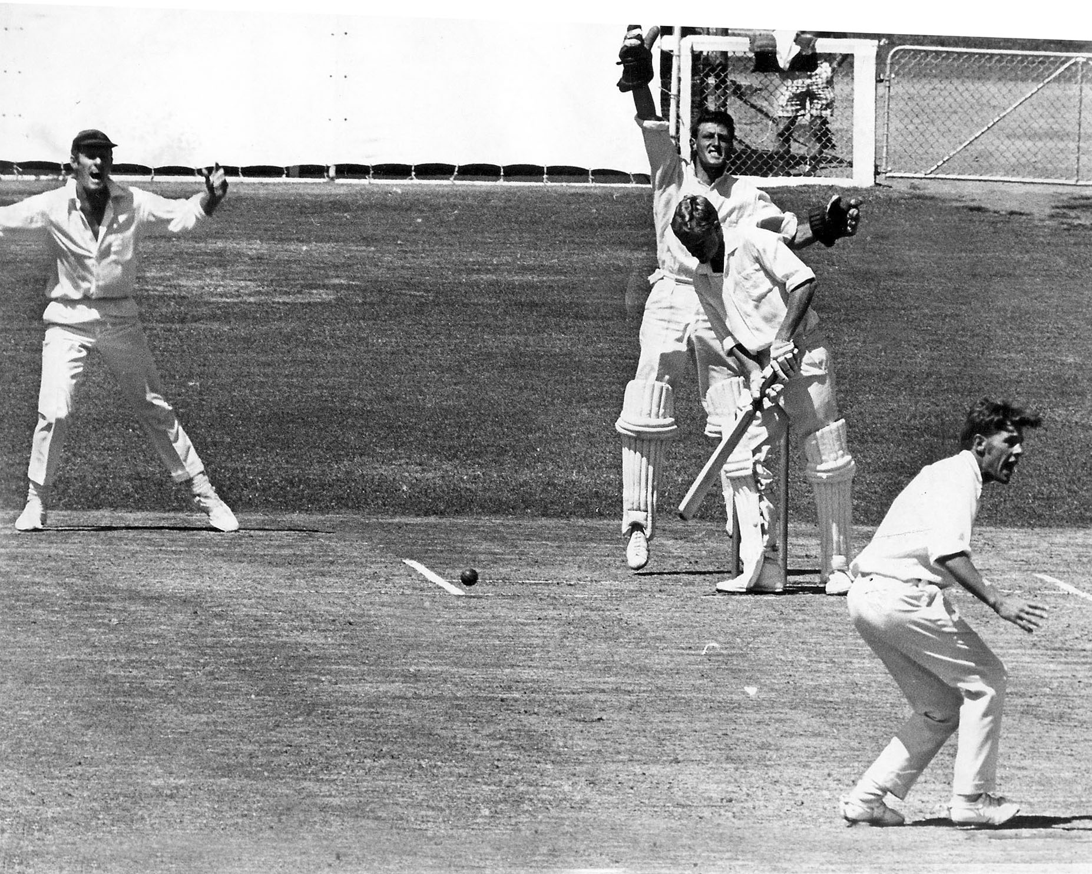

**Chris Kirk removes Rex Hooton lbw for 16 Lancaster Park 31 December 1969.**

**John Ward wicket keeper and Terry Jarvis slip.**

**Northern Districts 237 and 285/7declared Canterbury 315 and 70/2. Match drawn**